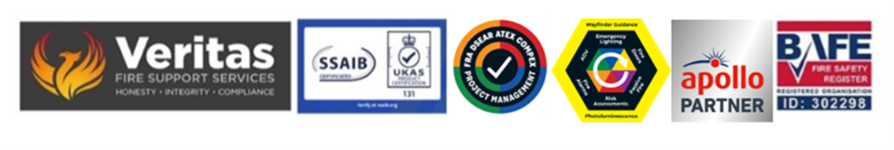April 2026

Notes for the RP in respect of the choice of fire risk assessor

Following recent publication of various documents from both MHCLG and other government bodies there is still a really significant failing in the appreciation of consequence for what happens in the event that the risk assessor cannot or does not meet the criteria for “competence” which is the primary requirement of Article 9 and will be what they are judged against by enforcing authorities in the event of an incident or inspection.

The current position is that to be able to meet the competency requirements if you are in court in front of a judge or a prosecuting barrister is UKAS third party certification.

Works done outside of this will fail the due diligence test and as a result leave the appointee and the provider in significant danger of compromise and from that potential prosecution for such failings, the appointee for the breach of Article 9 and the assessor for failing to meet the “suitable and sufficient” requirement.

The base line for this conversation is that the only certainty for meeting the requirements is to only use providers on the BAFE SP2O5 register and who have their ID number that you can reference against.

On an ongoing basis there are still people being prosecuted for failing to meet the criteria and the consequences for the RP are now very onerous indeed.

Cost is not the primary factor with this work, knowledge, expertise and experience are the only issues that need to be considered and if an appointment is made without these criteria being met then there will be serious issues in the event of a brigade inspection let alone a fire.

It is essential that the RP is fully cognisant of both the requirement of Article 9 and the consequences both in terms of personal and corporate liability which now carry unlimited fines and other serious penalties.

Steve Dilloway BAFE SP205 Certified Risk Assessor ID 302298

