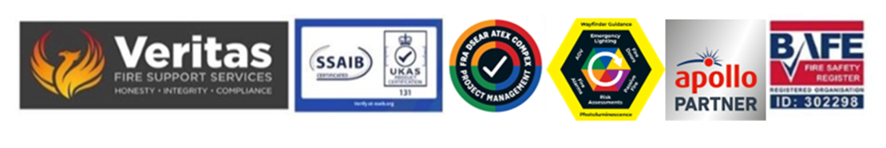

April 2025
Understanding and making appreciations of your Commercial Insurance

It is essential that for the Responsible and/or Accountable Person(s) identified in a Fire Risk Assessment to fully cognisant of both the legal and commercial consequences of having the very best commercial insurance cover, especially when considering the need for disclosure of previously identified non-compliance issues for the building and that accurate costs for long term consequential loss cover has been provided.

Statistically 70% of businesses that have a fire do not fully recover and more than half do not recover at all.

The main reasons for this are (1) under insurance for consequential loss and (2) non-disclosure of material facts to their provider.

The FRA would become the prima-face evidence for both the brigade and the business insurance provider in the event of an inspection or a fire so it is absolutely essential that all of the information provide is both understood and where required disclosed to your underwriters.

Taking particular attention to 1 and 2 above is absolutely essential for you so a full and frank discussion with your broker or other intermediary is a must.

Giving them access to this report and all associated documentation is strongly recommended as will be regular and ongoing engagement with them to ensure that if you have need of the policy cover you will have all the protection required for the business to continue in a post fire environment.

Steve Dilloway BAFE SP205 Certified Risk Assessor

