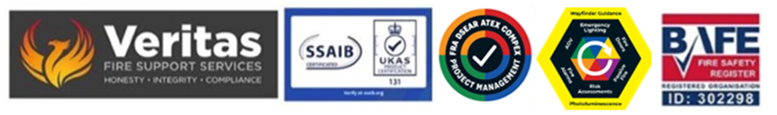
January 2026

Fire Action Notices & Signage
Safety Signage – Colours and Hazards

Health and Safety signage is an important communications tool that can help indicate various risks and hazards that the workplace may present.

There is a wide range of health and safety signage available that can be used in a variety of working environments from warehousing and distribution, construction sites as well as offices and retail.

Signage greatly increases staff and visitor’s safety awareness within a building especially where they are new or where disorientation is likely on larger sites, and these will help reduce the risk of workplace accidents – or worse.

Since the introduction of the mandatory provision of safety signage the rate of fatal injury has reduced by over 50%.

There are 4 main types of safety signage.

Red Indicates the potential for immediate danger, this means that action must be taken or that something is prohibited.

Yellow and Amber Indicates that precautionary steps should be taken to ensure safety in these areas.
Blue is a mandatory instruction and will often accompany a safety notice and/or danger or warning signs.
Green is a safety sign used to indicate safe escape routes and 1st Aid points.

To comply with current HSE requirements under the Safety Signs and Signals Regulations 1996 employers and landlords must provide adequate health and safety signage in the workplace or place of business and as a result hazards and accidents within these environments can be reduced.

2023 changes to the ability to see and quantify both distance and visibility.

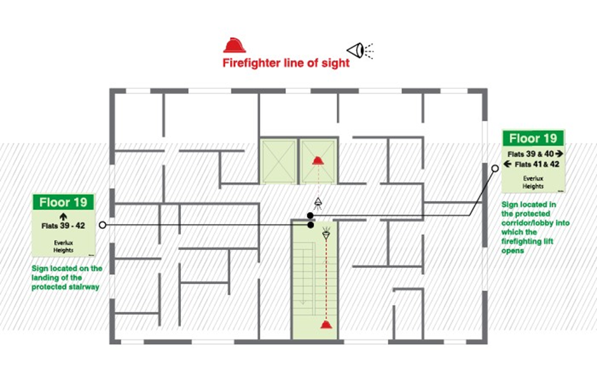

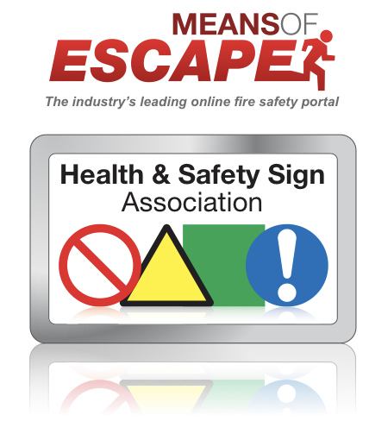

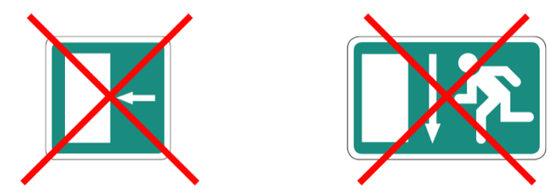

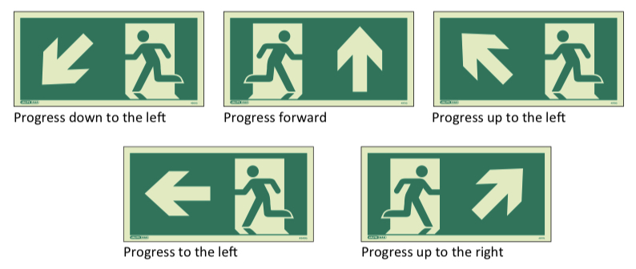

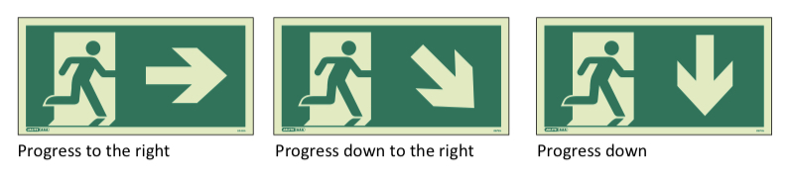

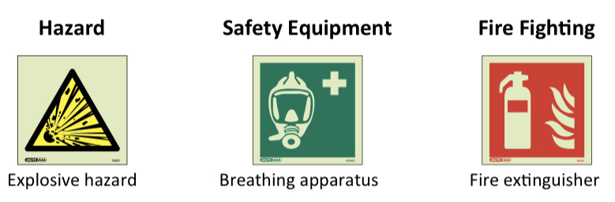

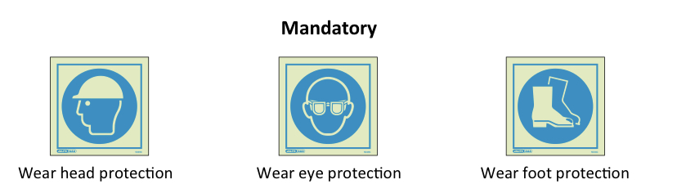

Steve Dilloway BAFE SP205 Certified Risk Assessor ID 302298

