
January 2026

Guidance notes for the RP 2
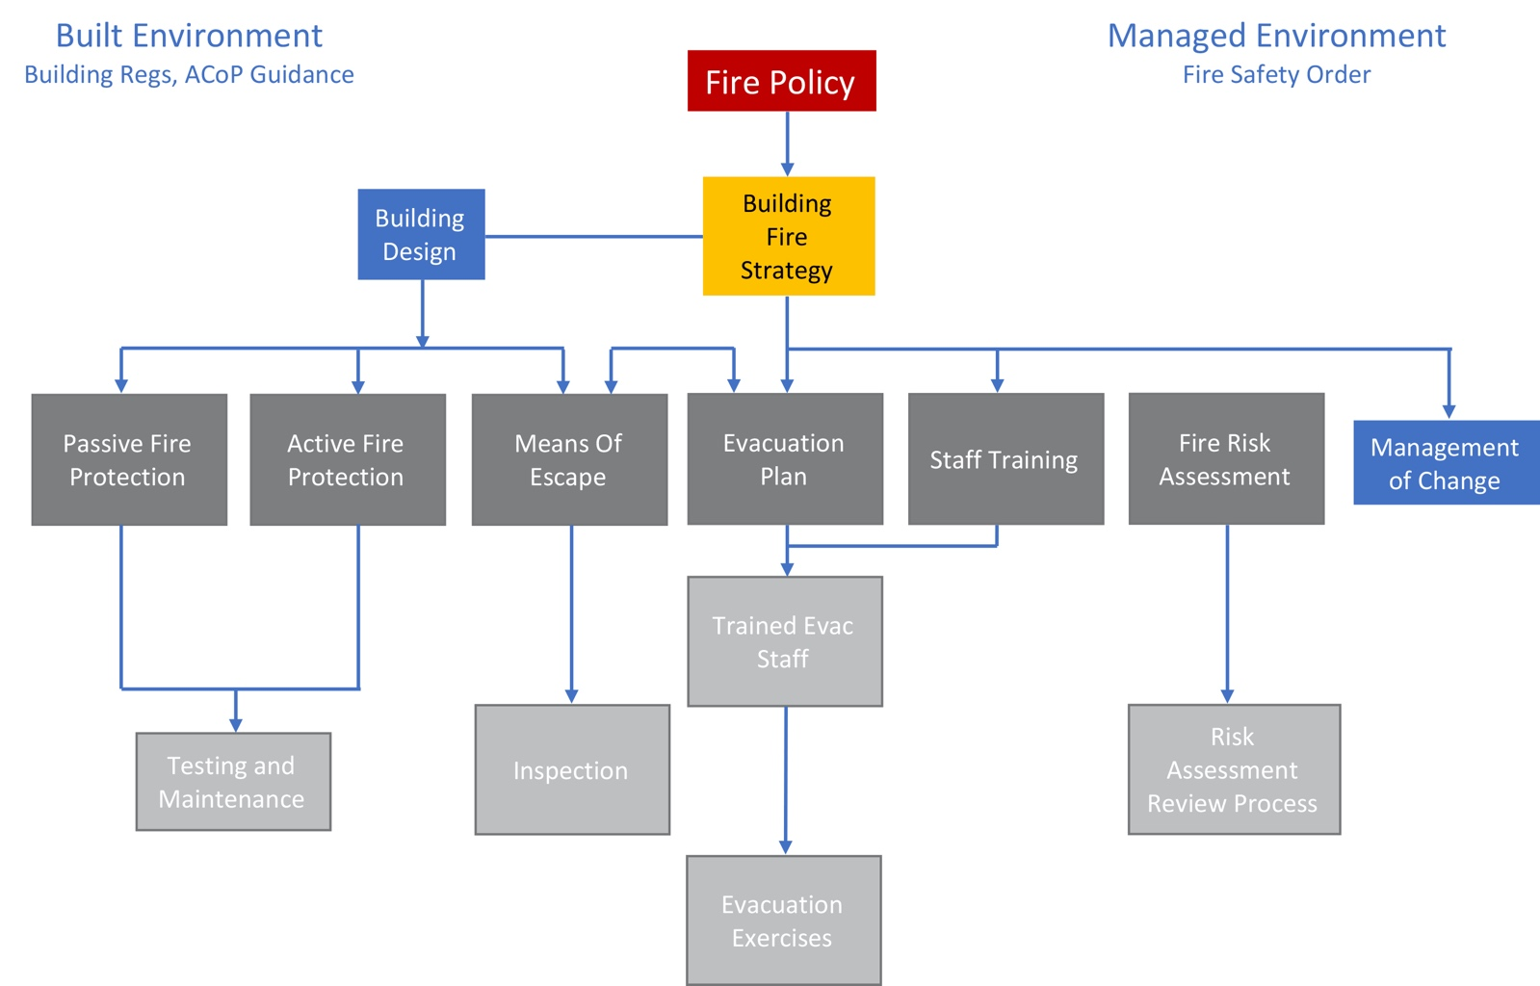
Steve Dilloway BAFE SP205 Certified Risk Assessor ID 302298/FIA risk assessment council member 2026

