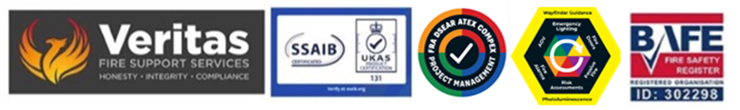
January 2026

Compartmentation and Fire Door summation and guidance January 2026

The following information is relevant to the fire door and compartmentation of the site and in particular the issues of UKAS certification and the need to follow due-process.

The provision of compliant door and compartment elements to your building impacts not only the day to day use of the building but also becomes both a disclosure issue to your insurance company and impacts on your fire strategy overall for the site so the need for issues to be correctly identified is essential and this can only be done under a UKAS certified scheme, i.e. IFC or BM Trada to allow for both survey, assessment, remediation and certification.

Pre-existing doors known as nominal or notional doors also need to be assessed and included within the plan for the site post publication of the FRA and potentially a re-publication of the strategy if that has been impacted by any non-compliance problems.

Ongoing service and maintenance of the site doors, including ironmongery is also a mandated element of current fire safety legislation and must be factored into the overall support plan and again this needs UKAS certification to underpin the site.

Compartment repairs likewise must be undertaken within a UKAS program and both persons undertaking the work and the products used to ensure compliance within the current standards and building regulations.

Site drawings need to be current and include, not only compartment lines (on means of escape) and the locations of all the fire doors and their fire rating however this has been considered.

A full site wide asset list is also required.

Steve Dilloway BAFE SP205 Certified Risk Assessor ID 302298

