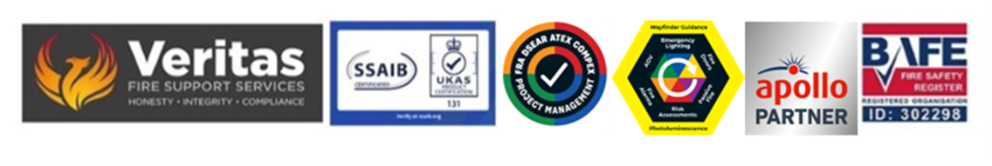December 2025

Report abbreviations for reference

• BAFE – British Approvals for Fire Equipment/ SSAIB – Security Systems and Alarms Inspection Board
• ECA – Electrical Contractors Association
• IFE – Institute of Fire Engineers
• PAFSS - Pneumatically Actuated Fire Suppression Systems
• LPCB – Loss Prevention Certification Board
• COSHH – Control of Substances Hazardous to Health
• Dsear – Dangerous Substances and Explosive Atmospheres Regulations
• PTW – Permit to Work
• AOV – Automatic Opening Vent
• ARC – Alarm Receiving Centre
• UKAS – United Kingdom Approvals Scheme
• RP – Responsible Person
• NFCC – National Fire Chiefs Council
• FSB – Fire Safety Bill
• PAS – Publicly Accessible Specification
• ADB – Approved Document B – known otherwise as building regulations
• BCP – Business Continuity Plan
• ECR – Electrical Condition Report
• LPS – Loss Prevention Scheme
• SCA – Smoke Control Association
• NICEIC – National Inspection Council for Electrical Installation Contracting
• RRO/FSO – Regulatory Reform Order – Fire Safety Order
• CAD – Computer Aided Design
• BRE – Buildings Research Establishment
• EL – Emergency Lighting
• GSM - The Global System for Mobile Communications
• PIB/SIB – Premises Information Box/Site Information Box
• HVAC – Heating Ventilation and Air Conditioning
• AFDD – Arc Fault Detection Device
• O/M – Operational Manual
• BCO – Building Control Officer
• MHCLG - Ministry of Housing, Communities & Local Government
• HMG – His Majesty’s Government
• CDM – Construction Design and Management
• TPC – Third Party Certification
• ART – Approved Repair Techniques
• FRS – Fire and Rescue Service
• SOP – Standard Operational Procedures
• AS – Anti - Static
• IS – Intrinsically Safe
• CIBSE – Chartered Institute of Building Service Engineers
• MSDS – Material Safety Data Sheets
• D/O – Directors and Officers (liability insurance)
• BESA – Building Engineering Services Association
• CBU – Central Battery Unit
• DDA/SN – Disability Discrimination Act/Special Needs
• DB- Decibel

Steve Dilloway BAFE SP205 Certified Risk Assessor ID 302298

