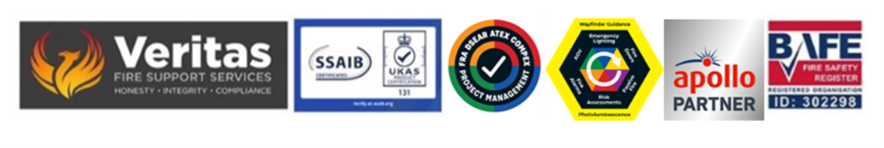

Disability support notes for the RP

In respect of the identification of disability and special needs support on site the Accountable Person or Persons must ensure that adequate work is done to ensure their understanding of the building and those within it (including temporary visitors and contractors) and as such the issues must extend to include the obvious as well as the unseen issues and this later element is the most complex, it will need to include regular engagement with staff and for interview process for new incoming staff must include references to all of the following which is not an exhaustive list and is not in an order of priority:

• Persons with temporary impairments
• Ladies who may be pregnant
• Photosensitive Epilepsy
• Colour Blindness
• Vertigo
• PSTD
• Autism is its various elements across the spectrum
• Impaired hearing
• Persons on prescription medication which might affect their ability to react to an evacuation or impact on others trying to evacuate.

This bulletin should be issued to existing staff who are asked to discuss in confidence any issues they want to make the management aware of their own circumstances and as part of any future interview process for new incoming staff.

Steve Dilloway BAFE SP205 Certified Risk Assessor ID 302298

