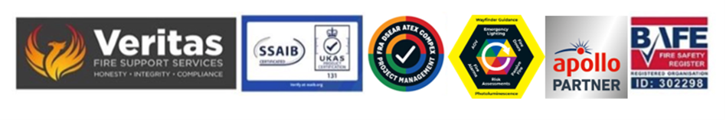
August 2025

Addendum to BS 9792-2025 for Housing Applications.

Following the publication of BS 9792 the following elements are now relevant to an FRA with a sleep-in provision and need to be adequately understood by the Nominated Responsible Person, this term for sleeping sites has replaced that previously used and understood as the RP.

This new Code of Practice provides a comprehensive framework and documentation examples for assessing fire risks in residential settings, taking into account the latest legislation and fire safety standards.

It introduces a “clearer structure, streamlined commentary, and a refreshed pro-forma for documenting fire risk assessments”.

Aimed at competent persons carrying out fire risk assessments (the BAFE certified assessor) and freeholders, managing agents, management companies and housing providers, it gives some direction which can be applied to a broad range of residential premises, including:

- Houses in Multiple Occupation (HMOs)
- Blocks of flats or maisonettes (purpose-built or converted)
- Specialised housing (as defined in the standard)
- Student accommodation in any of the above forms
- Access areas to residential spaces in mixed-use buildings

As BSI states, the standard has been designed to allow assessors to determine the proportionate measures to help protect occupants and those nearby and in adjoining buildings from fire hazards, with updated guidance for individuals with specific evacuation needs also included, this may be (1) immediate simultaneous evacuation
(2) stay-put (if the fire door and compartment provision allows for this and (3) defend in place normally used in care and supported living sites where full occupation increases the risks to persons who are vulnerable or cannot self-evacuate.

As such, the standard sees a full revision and formal upgrade of PAS 79-2:2020, following its withdrawal in 2020.

It is hoped that this will give a clear focus on inclusivity, legal compliance, and modern best practice, BS 9792:2025 also complements standards such as PAS 9980 (external wall fire risk appraisals) and the forthcoming BS 8674 (competence for fire risk assessors).

BSI’s view is that the issue of fire risk in residential accommodation should be front of mind for the whole sector, to be aware and understand the risks and to protect people, it is critical that we ensure all standards reflect the latest evidence.

The publication of this updated guidance marks a major step forward for residential fire safety. It is designed to deliver clarity, consistency, and assurance for housing providers, assessors, and all those committed to protecting lives, it is supposed to set a new benchmark for safety planning and reflects a strengthened and collaborative commitment to transparency and the needs of diverse housing communities.

Steve Dilloway BAFE SP205 Certified Risk Assessor

