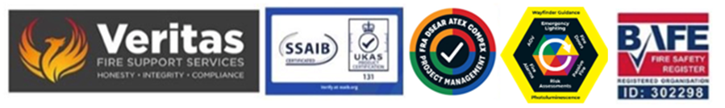
February 2026

Understanding the requirements of the current legislation and the needs of and for the RP in terms of both the expectations of the brigade and other stakeholders and in terms of the information provision for future FRA reports.

Following the changes made in the 2023 Fire Safety legislation the levels of knowledge and information expected of the RP are both more onerous and litigious if not met so it is now more important than ever that the RP is fully cognisant with his/her responsibilities and also the consequences of not.

The expectation of the enforcing brigade authority is that you will have immediately available if requested ALL of the following:

Current FRA
Current Fire Strategy
Full staff/occupancy training
FD&A + EL service plan and lists of deficiencies
Fully populated and up-to-date log book – hard copy and cloud based
Fire Door and Compartmentation validation report and remediation plan where required

All of the above are also actually a requirement for a future FRA so you’d be expected to have them already but, if your current plans for documentation and recording of testing and training are not in line with current requirements you’ll already be in breach of elements of these new requirements.

Your responsibility extends to understanding the requirements of Article 9 in terms of the instruction of an FRA provider who is deemed competent and suitable which in reality is UKAS/BAFE certification and this extends also to the other fire and life safety elements of your property – fire alarms & extinguishers, lighting, signage, smoke extraction, electricals including lightening and surge protection, fire doors and compartmentation, disability planning + provision and staff training in fire marshalling and evacuation.

Potential issues with the brigade if you are not where you need to be will be significant and could impact on both insurance and licensing of your building.

The purpose of this bulletin is to ensure you are as “aware” as possible to ensure that when requests are made for information you know where you need to be.

Should you want to discuss in more detail where there might be gaps in your documentation and/or the support currently provided then please feel free to get in touch.

Steve Dilloway BAFE SP205 Certified Risk Assessor ID 302298

