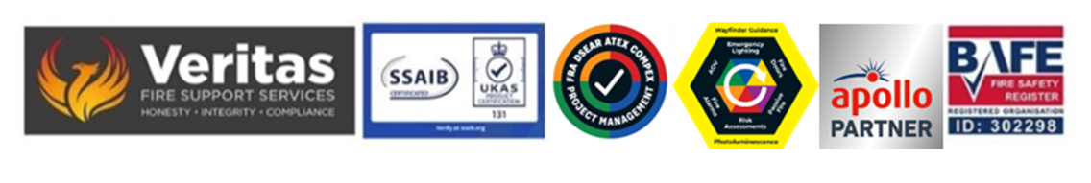
April 2026

There are serious concerns over the storage of, and access to the alcohol stores within the rooms designated as wine stores and cellars adjacent to the kitchen areas, what must be considered here is the flashpoints for the various alcohols stored here within, as a result of these issues, both doors for these rooms need to be FD60 and that all of the compartmentation elements, ceiling issues need to be 100% so that if there is a breakage where vapour is released that, if a fire situation develops it is contained within the room and does not compromise an escape route.

In respect to Alcohol spirit, the most important factor to consider is Flashpoint.

Where manufacturers MSDS * are not available, the following data may provide some guidance

Liquor that contains 40% ABV (alcohol content) will catch fire if heated to about 26 °C and if an ignition source is applied to it.

The flash point of pure alcohol is 12°C, however, nominally the spirit industry use 96% alcohol which has a flash point around 16.6°C, less than average room temperature.

Therefore any deficiencies in the internal AC within this area could potentially lead to a significant issue, it must therefore be adequately maintained to avoid increases in the ambient internal temperature.
The flash points of alcohol concentrations from 10% ABV to 96% ABV are generally accepted as follows:

. 10% — 49 °C — ethanol-based water solution
· 12.5% — 52 °C — wine
· 20% — 36 °C — fortified wine
· 40% — 26 °C — typical vodka, whisky or brandy
· 50% — 24 °C — strong whisky
· 60% — 22 °C — normal tsikoudia (called mesoraki or middle raki)
· 70% — 21 °C — absinthe, Slivovitz
· 90% or more — 17 °C — neutral grain spirit

NOTE: Flammable vapor generation only occurs at operating temperatures above the "Flashpoint" of the product.

Thus, If the Alcohol Spirit percentage ABV is Larger than 20%, then generally, flashpoints will exist at temperatures lower than the UK maximum "Ambient Temperatures" of the Summer months.

Therefore in the event of alcohol spillage, sustainable flammable vapor release is likely to occur, until such time as the spillage is removed / cleaned up – thus spill kits are to be provided in the locality for such a situation.

As a result of the above the current levels of fire detection are to be increased in the basement stock/stores area x 2 due to the potential fire issue from vapor thus increasing the speed of detection across these areas even though they are not large but the risk to losing the potential rear escape route is significant.

In addition all spurious packaging and waste from within the alcohol stores must be removed now and future situations monitored to avoid a build-up of potential fuel for a fire here.

Complications with vapour from a potential cracked bottle or bottles which may not be immediately evident but which could cause an explosion within the store area must be considered and as a further method of mitigation for a potential fire issue it is recommended that CCTV is added into both stores so that these areas can be monitored more closely.

Furthermore, the alcohol stores must be clear of any waste product, wrapping, wooden boxes and crates, promotional materials and the like to remove potential fuel for an accidental fire, this must be monitored and controlled especially when larger volumes of alcohol are kept on site such as for Christmas and New Year festivities, weddings and special functions, it is also assumed that, whilst not seen, alcohol is not stored elsewhere away from the 2 identified areas at any time.

Within the dining rooms bars and hospitality areas generally the use of candles/tea lights and oil diffusers must be managed and controlled again especially during festivities and parties to ensure that there is control over a potential situation with adequately trained staff and localised portable extinguishers available if needed, it is understood that this type of table décor cannot be totally prohibited but the hotels on site SOP for parties and events must take this into account especially when ceiling decorations are also in use.

The use of the above should not be permitted anywhere within the guest rooms or suites.
From a cooking perspective it is assumed there is no flambe cooking at guest tables.

As a footnote to this, there was no evidence at the time of writing of external events outside of the hotel itself so no comments can be made as to potential issues (in better weather) if there was hospitality outside adjacent to the main entrance and thus if this is a likely scenario then the FRA needs to be re-visited.

• Material Safety Data Sheets – these must be updated every 3 years in accordance with guidance and should be available from your vintner partner.

Steve Dilloway BAFE SP205 Certified Risk Assessor ID 302298

