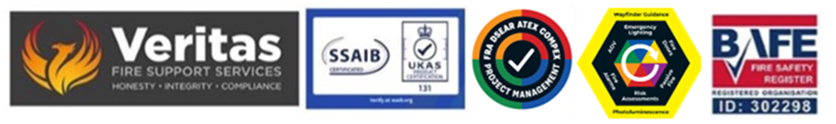
January 2026

Basic appreciations of BS 5839-1 2025

M Category Systems – Manual Only

This is the most basic & simplest of systems and provides basic protection via break glass call points and sounders only, the system will have no automatic smoke or heat detection devices, in the event of a fire it has to be manually operated by activating one of the call points, in this respect therefore an M system is unsuitable for an unoccupied building.

L Category Systems

Category L systems are automatic fire detection systems intended for the protection of LIFE: All L systems will also include all of the criteria on an M system.

L5 – Often an L5 system will be based upon a risk assessment or a fire engineering solution, or for detection provided as part of a building management package i.e., smoke control system. Where the risk assessment is used as the basis for the system design it should be understood that this will have been provided by others (Landlord, Insurance Building Control etc.) and may have other factors which may also need to be considered.

L4 - Allows for automatic fire detection installed within those parts of the escape routes comprising circulation areas and circulation spaces such as corridors and stairways.

The objective of an L4 system is to warn occupants of smoke within an escape route.

L3 – Will include all of the criteria of an L4 system but also requires for automatic detection in rooms that open onto the escape routes from the building, the objectives of this category of system is to enable all occupants to safely escape before the smoke level increases to levels where the escape routes cannot be used safely.

L2 - Will include all of the criteria of the L3/L4 systems but will also require automatic fire detection in additional parts of the building designated as “high risk” and may include but not be limited to, kitchens, boiler rooms, storage areas etc.

The purpose of this type of system is identical to that of an L3 system with the additional objective of affording early warning of a fire in specified areas of high risk, the use of L2 systems is most common in sites with sleeping accommodation such as hotels, hostels, B&B’s etc.

L1 – Are designated to provide automatic fire detection in ALL areas of the building, with the possible exception of pre- agreed areas of low risk and may include the following:

• WC’s, Shower Rooms and Bathrooms
• Stairway and WC Lobbies
• Small Cupboards – Typically less than 1m sq.
• Small Risers – Typically less than 1m sq. provided that they have fire resistant floor and ceiling boards
• Shallow Voids – Typically less than 800mm in depth – shallow voids may also be included subject to site specific issues.

The objective of an L1 system is to offer the earliest possible warning of fire so as to provide the longest possible period of evacuation time for occupants.

Systems which are providing coverage for buildings with public access and where a sleep-in capability is included must now meet EN54 Part 23 for VAD’s – Audio Visual Devices (July 2013)

P – Category Systems

Category P systems are designed to provide automatic fire detection for property and DO NOT include the requirements for an M system.

All category P systems MUST be connected to an alarm receiving centre (ARC) for direct brigade response, the British Standards requires that this be done via a dedicated telephone line and should not as such be added to an existing intruder alarm signalling package, it should be an outgoing only line and free of all third party traffic.

Because these systems provide protection for property and business interruption they are most favoured by insurance companies.

P2 – Systems allow for automatic fire detection within pre-defined parts of a building posing a high risk of fire or areas of high risk to property or business continuity from high risk of fire including automated plant and boiler rooms, battery charging rooms etc.

P1 – Systems will provide for automatic fire detection in all areas of the building with the sole exception of low risk voids (ceiling and floor) typically but not limited to less than 800mm in depth.

Steve Dilloway BAFE SP205 Certified Risk Assessor ID 302298

